**Installation of Power BI Desktop**

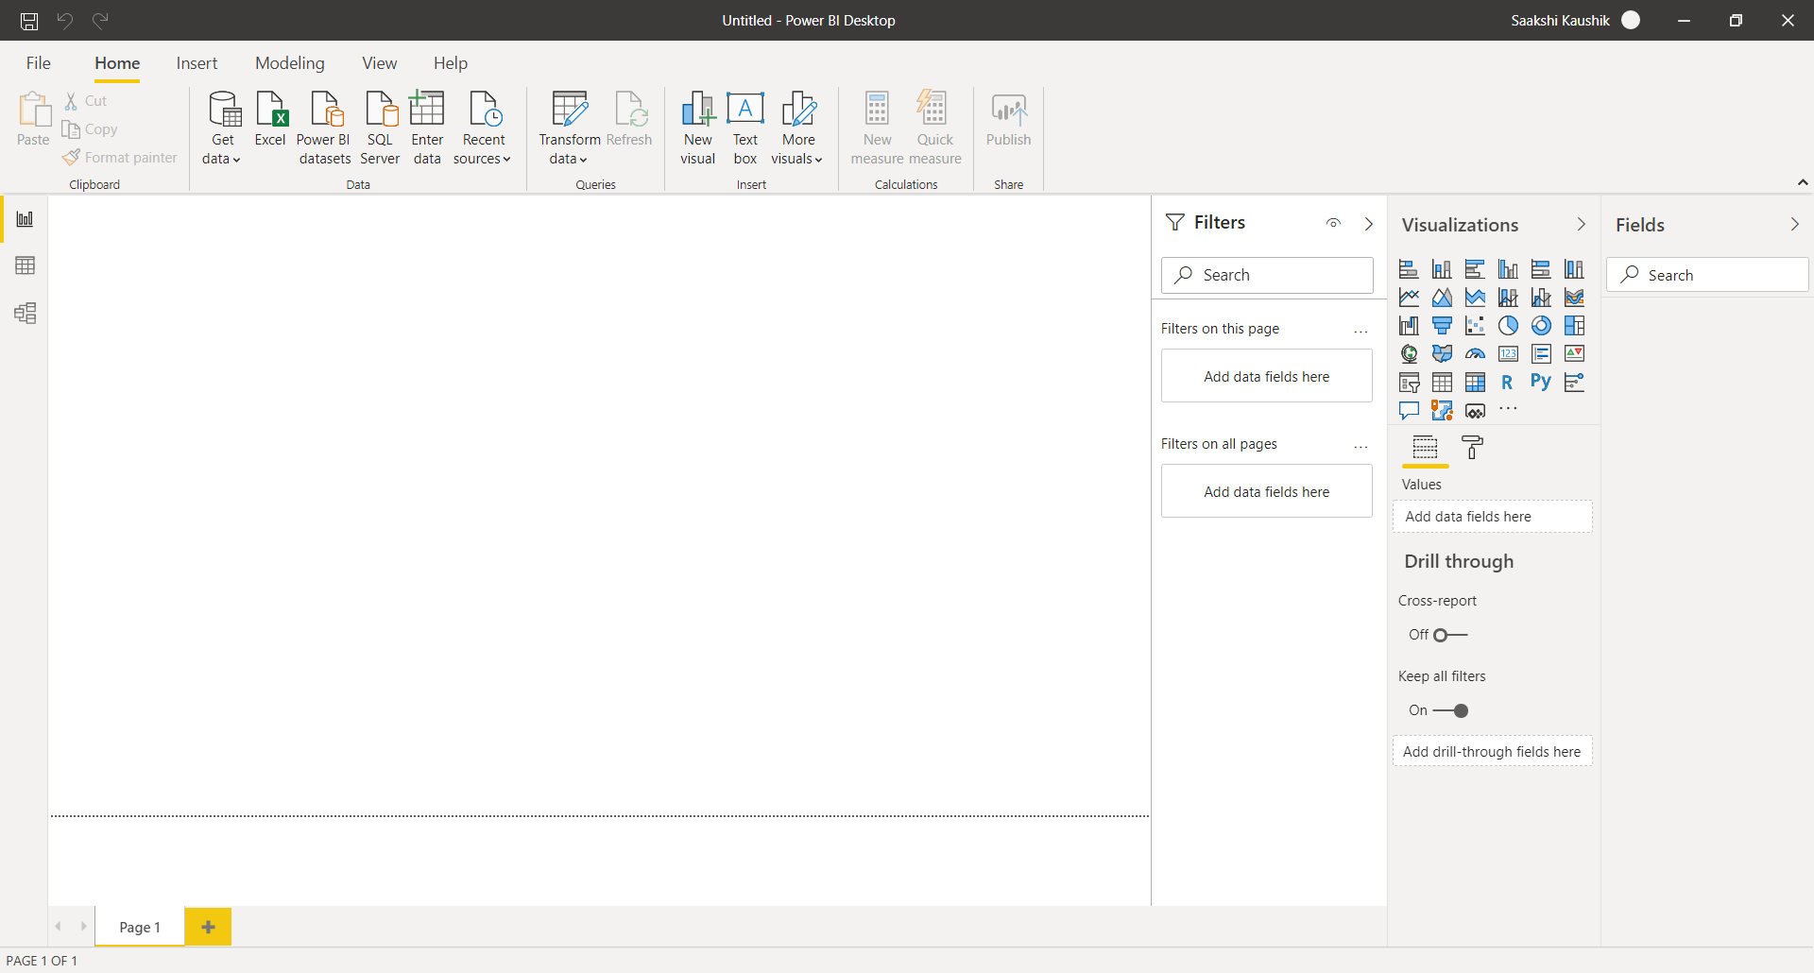

**Report View**

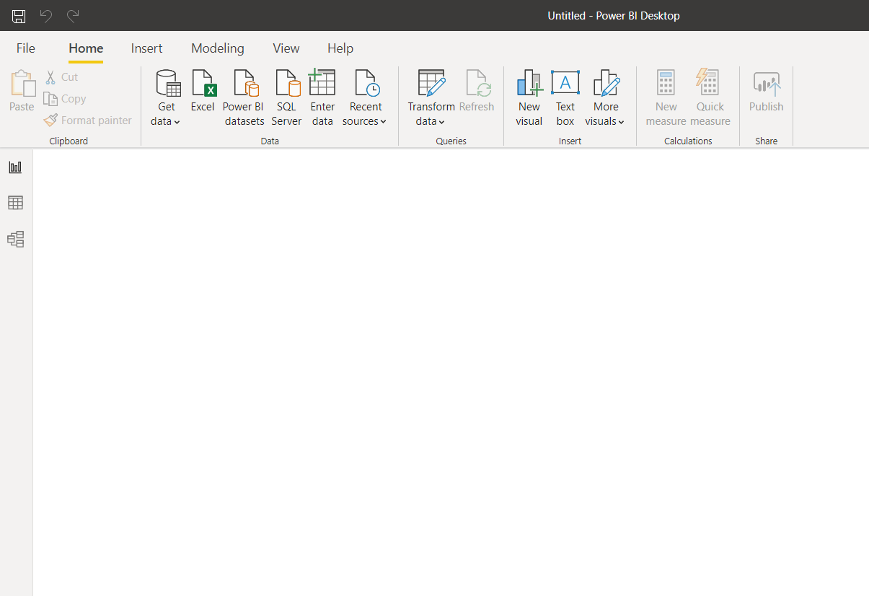

**Data View**

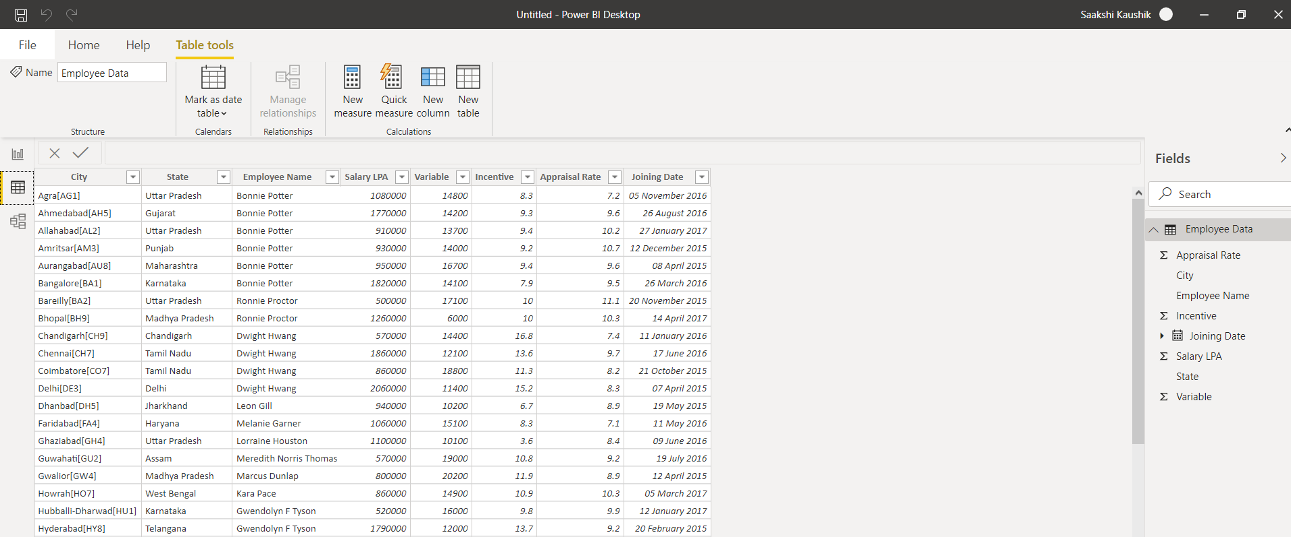

**Model View**

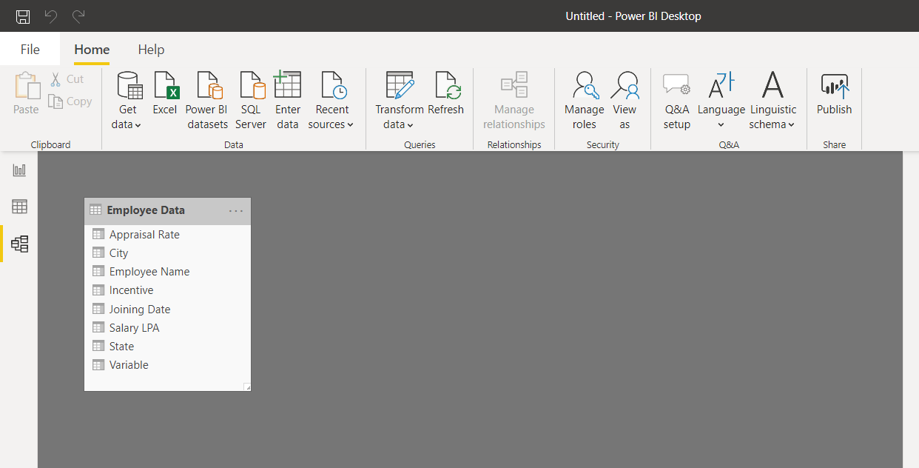

**Power Query Editor**

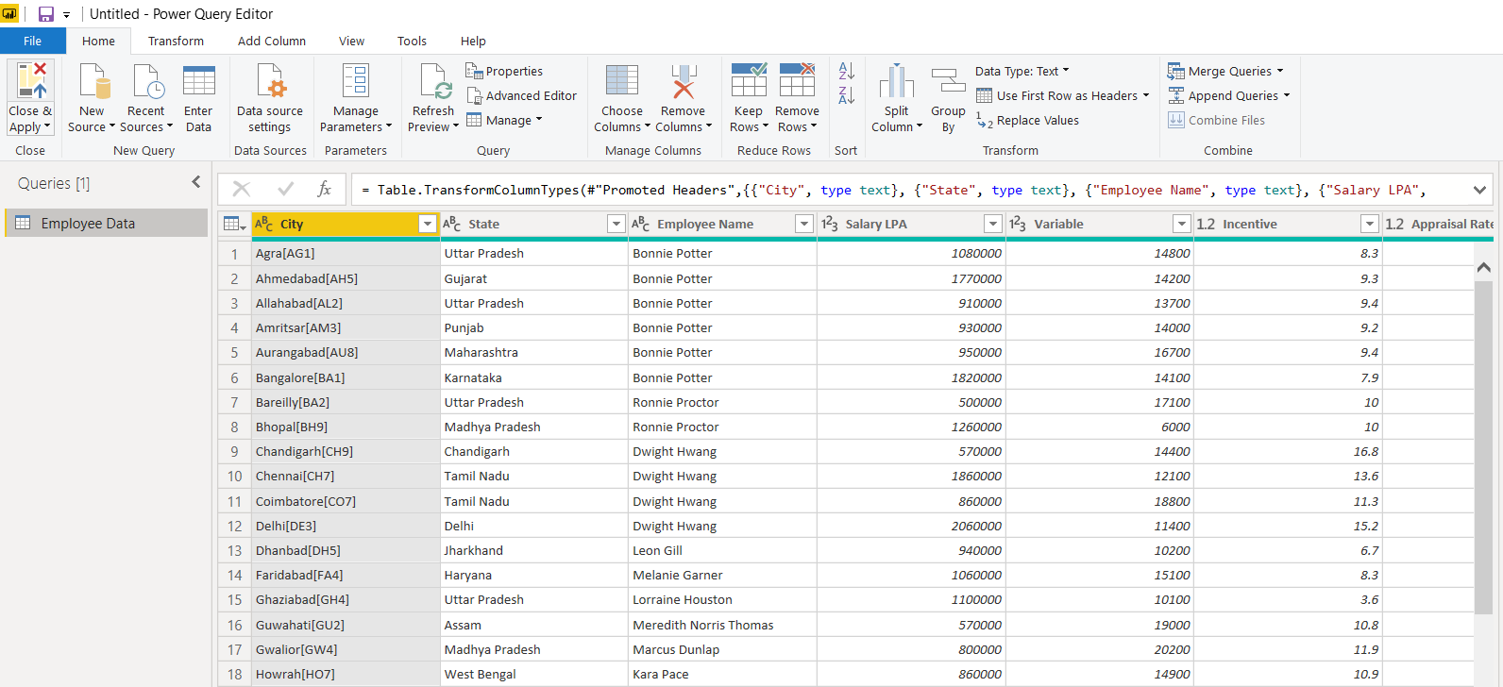

**Advance Editor**

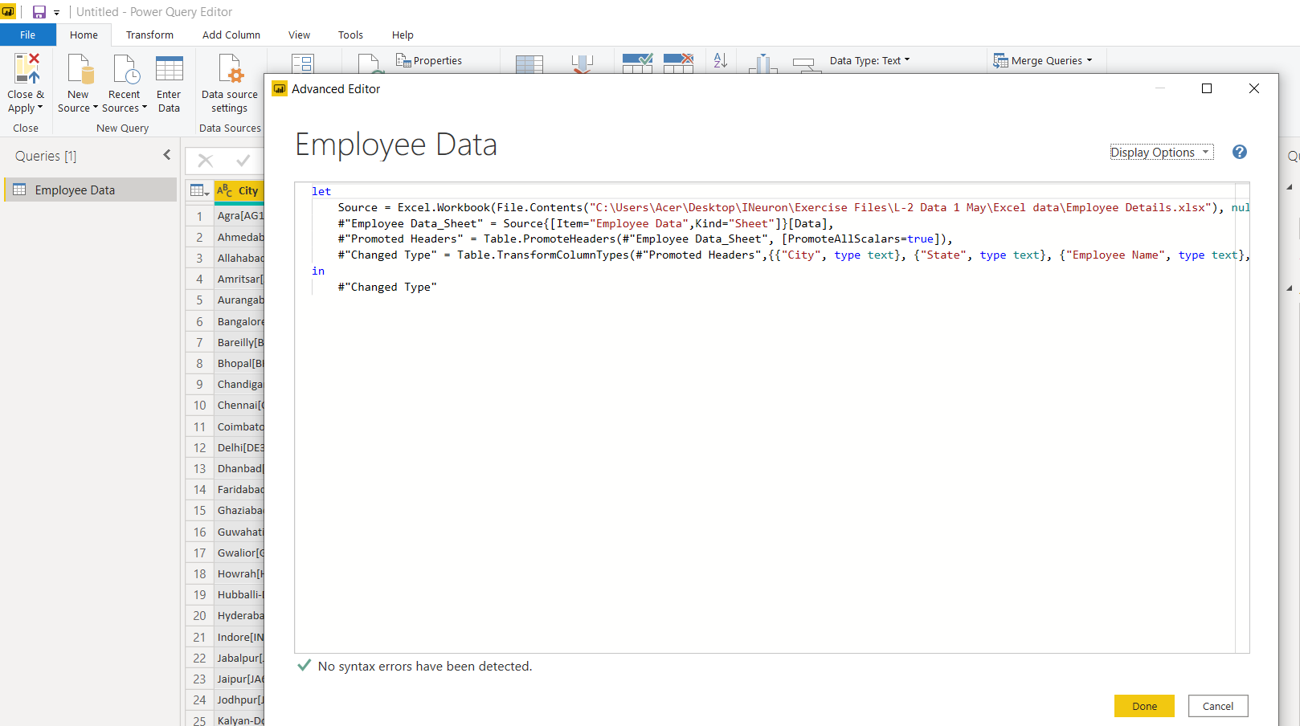

**Power BI Desktop:-**

Power BI is an analytic tool which allows us to connect the data from multiple sources & once connected allows us to shape & transform the data in order to perform some analysis. You can perform that analysis by producing interactive reports and then publish it to power bi service and can share it with people within the organization who can then view the report on the web and on their mobile devices also.

It helps you to gain insight in business which helps you to make better business decisions.

Power BI Desktop is free.

**Power BI Pro:-**

Power BI Pro is a type of license which allows control access to the content you post using Active Directory Groups or Office 365 Groups. even create new Office 365 Groups.

In this, users are licensed individually. If you have 10 people that need to get Power BI, then you need 10 licenses. With Power BI Pro there is limitation of 10GB Data and data is refresh hourly.

Power BI Pro is currently $9.99 user/month.

**Power BI Premium:-**

Power BI Premium is designed for large scale BI deployment & enterprise tools and you don’t get it individually. With this, you are not buying individual licenses, you are buying a “BULK” for your company. This feature allow anyone in your organization to get in & view the content.

The **Premium** plan starts at $4,995 a month per dedicated cloud compute and storage resource.